LEGAL NOTICE
THROUGH REGISTERED A.D./SPEED POST/EMAIL/WHATSAPP
To,
[Client Name]
[Client Mobile Number]
[Address]
Subject: Legal Notice for Recovery of Dues and Intimation of Filing Police Complaint before Jurisdictional SHO
Sir/Madam,
That we, AMA Legal Solutions®, a duly established legal consultancy firm, through our Authorized Representative, do hereby serve upon you the present Legal Notice as under:
- That you had engaged our firm for providing professional legal services pursuant to an engagement dated {startDate}, which was duly accepted by you either expressly and/or by conduct, including continued availing of such services.
- That as per the agreed terms and conditions, you were liable to pay professional fees amounting to INR _______ within the stipulated time.
- That pursuant to the said engagement, our firm duly rendered professional services including but not limited to legal advisory, drafting, consultations, compliance assistance, and/or representation, to your satisfaction.
- That despite rendering the agreed services, you have failed and neglected to clear the legitimate dues payable to our firm.
- That as on date, a sum of INR _______ (Rupees ______ only) remains outstanding and payable by you towards professional fees.
- That repeated requests and reminders have been made to you for clearing the said dues; however, you have failed to make the payment till date.
- That your aforesaid acts amount to breach of contractual obligations and have caused financial loss and inconvenience to our firm.
- That you are hereby called upon, through this Legal Notice, to make payment of the outstanding amount of INR _______ (Rupees ______ only) within 7 (Seven) days from the receipt of this notice.
- That in the event of your failure to comply with the above demand within the stipulated period, we shall be constrained to initiate appropriate legal proceedings against you for recovery of the said amount along with interest, costs, and other applicable charges, at your sole risk, cost, and consequences.
- That this notice is being issued to you without prejudice to all other rights and remedies available to us under applicable laws.
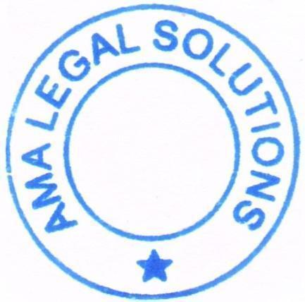

You are advised to treat this notice with utmost seriousness.
For AMA Legal Solutions®
Through Authorized Signatory

